April 15, 2024
HORSESHOE FALLS REGIONAL COUNCIL REPORT
I continue to forward the HRFC newsletter to those individuals who request it and snippets which I think would be of interest to others. The latest newsletter had a number of very interesting articles including the one below regarding the upcoming preparation celebrations for the 100th anniversary.
Save-the-Date: Day of Fellowship
Saturday, June 8, 10:00 am to 2:30 pm

President Lennox Scarlett cordially invites fellowship from Western Ontario Waterways and Antler River Watershed Regional Councils. Join us in June - the more, the merrier!
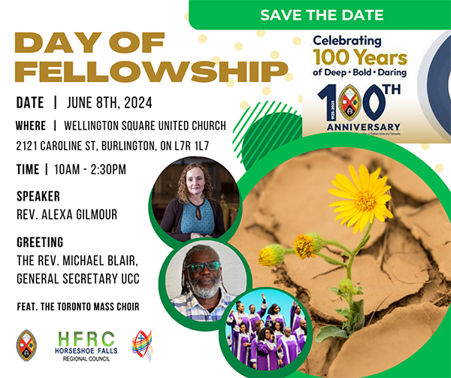

I have registered for the Tri-Council conference May 24 to 26 at Port Elgin and will be submitting my expenses to the Treasurer and chair of the Council to share with you. Council can decide what if any they wish to reimburse me.

I ordered 10 copies of the book celebrating 100 years of the United Church and because it was 10 copies the cost was reduced from $30.00 to $14.95 plus shipping and tax works out to $17.60 per book.

Last weekend I attended the Niagara Area United Churches (NAUC) meeting at Central United . This group replaces the former Presbytery and allows the area churches to share what they are doing thus helping to foster better co-operation and communication. This was the 4th such meeting and the next one will be held at Cave Springs sometime in June. These meetings are open to everyone!!!

Submited by Doug Willford.

