WHAT’S UP AT WESLEY
Thurs, Aug. 22, 2024

Newsletter for Wesley United Church, Welland

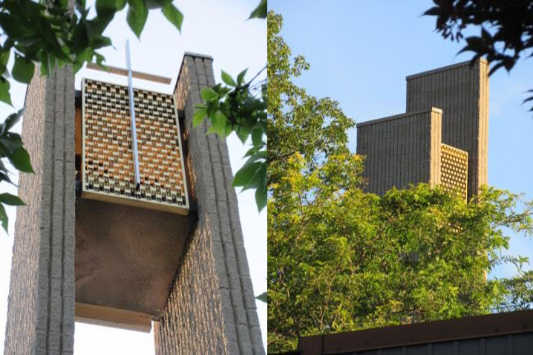

THE LONELY BOUQUET by Shelley Gault
In June, our church was one of two recipients to receive a "Lonely Bouquet" of flowers from Sobeys supermarket in Welland. Betty Kallendar, one of Wesley's congregants, enjoyed the beautiful floral arrangement. In thanking the owner of Sobeys, Mike Zolli, he informed me that this was a pilot project they were initiating, to give back to the community. He was very pleased to hear that it was a success at Wesley!!
WESLEY WEDNESDAY WALK IN NATURE

The next walk will be on Wednesday, September 4 ^{th} at 8:00 AM. We will park next to the Lock 7 Viewing Centre, 50 Chapel Street South, in Thorold. Everyone is invited to participate in this 40 minute casual walk.

BIBLE BULLETS

Rejoice always. 1 Thes 5.16
Pray without ceasing. 1 Thes. 5.17
Give thanks in all circumstances. 1 Thes. 5.18

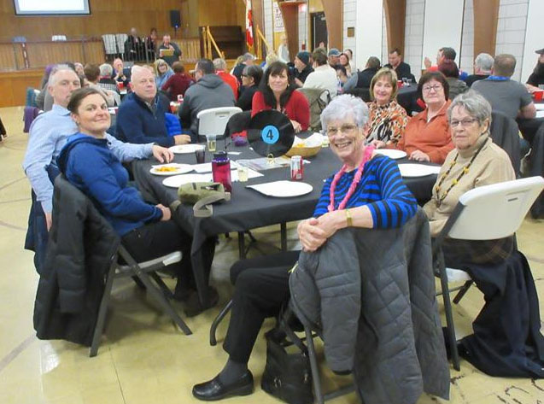
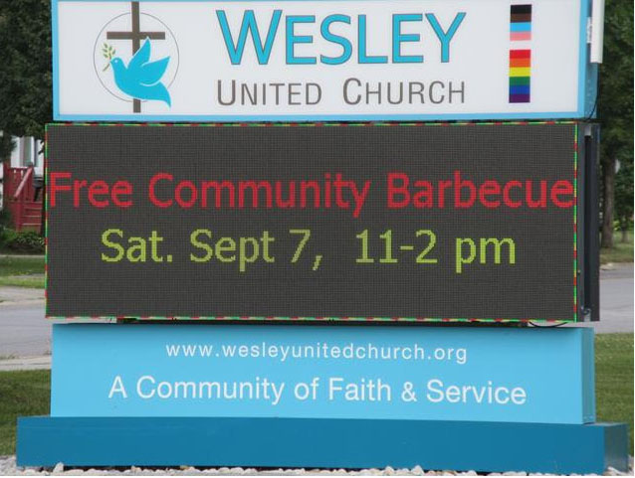

COMMUNITY BBQ AT WESLEY

SATURDAY, SEPT 7TH - 11 AM TO 2 PM
ACTIVITIES ARE FREE – FREE FOOD AND FUN
MEET WITH WELLAND’S FIRST RESPONDERS
REGIONAL POLICE AND FIRE FIGHTERS
WILL BE VISITING WITH A POLICE CRUISER
AND A WELLAND FIRE TRUCK
A Freewill offering will be taken to raise funds
for the Jasper Fire Relief
DATES TO REMEMBER

Sept 1 – Sunday Worship restarts – 10AM – at Wesley
Sept 2 – Labour Day – Church office will be closed
Sept 3 – Wesley Church Office will reopen.
Sept 4 – Wesley Wednesday Walk restarts at 8 AM – Meet next to the Lock 7 Viewing Centre at 50 Chapel Street South in Thorold. Everyone is invited to participate in this 40 minute casual walk.
Sept 7 – Saturday – Community BBQ at Wesley – 11 AM to 2 PM.
Sept 15 –Back to School Worship Service . The Seraphic Voices of Toronto Choir will be our guest. All students are invited to attend.
Sept 15 – Special Congregational Meeting following the church service to discuss and approve Sandy Graham as a new trustee and to approve the separation of the Membership and Outreach Committee into two new committees: #1. Membership and Pastoral Care Committee and #2. The Outreach Committee.
Sept 15 – Terry Fox Run Day in Ontario
Mid Sept – Seniors’ Activity Event at Wesley Church – ALL seniors are welcome to attend – it is FREE
Sept 22 – Wesley United Church Anniversary Service, 10 AM
Oct 4 & 5 – United Church of Canada Regional Council Meeting via Zoom. Registration opens September 5th at www.hfrcucc.ca, Horseshoe Falls Regional Council. You are welcome to sign up and watch the meetings.

